Practical 5

**AIM: To install and configure DNS server in Ubuntu.**

**Step 1:** Make sure your Ubuntu server is up-to-date, if not then use the update and upgrade command.

sudo apt-get update

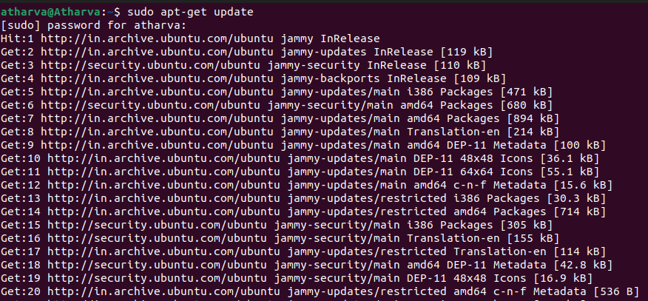

sudo apt-get update

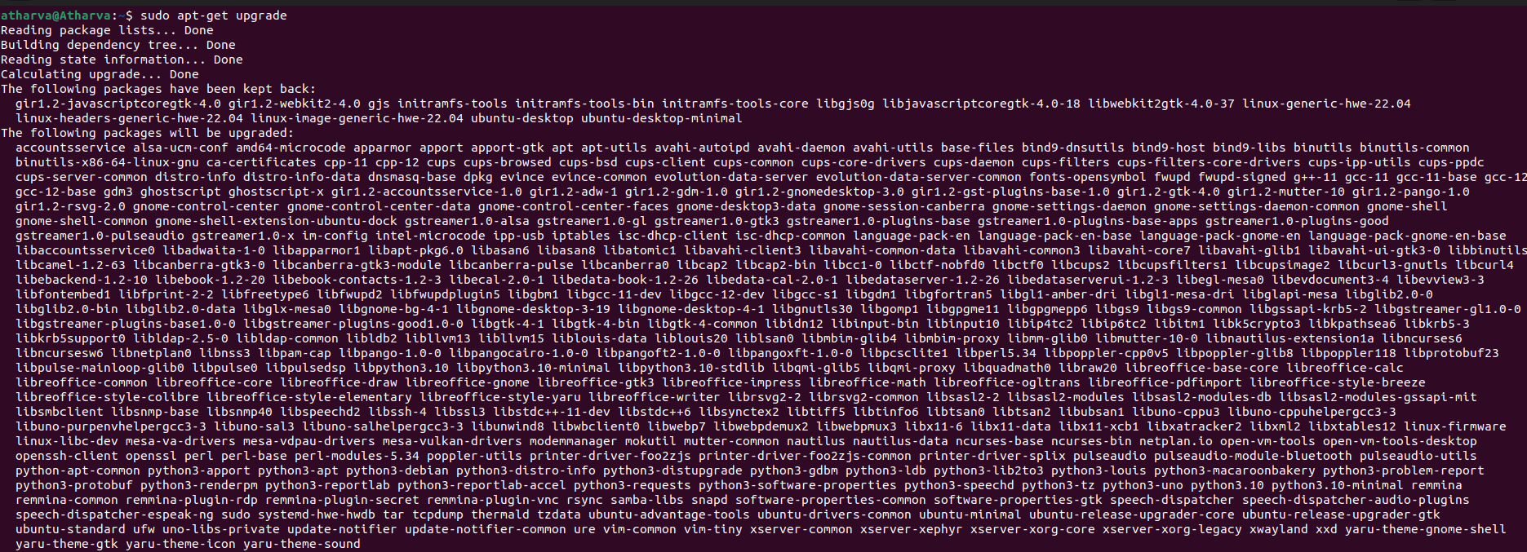

**Step 2:** After updating the system, run the following command to install BIND9 packages which are used to setup DNS server.

sudo apt-get install bind9 bind9utils bind9

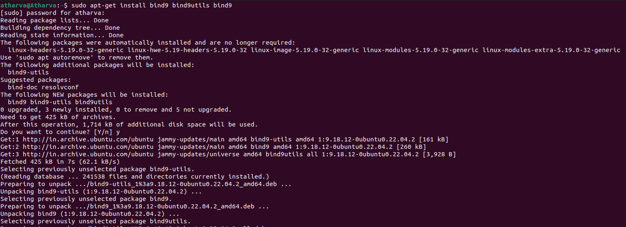

sudo apt-get install bind9 bind9utils bind9-docs

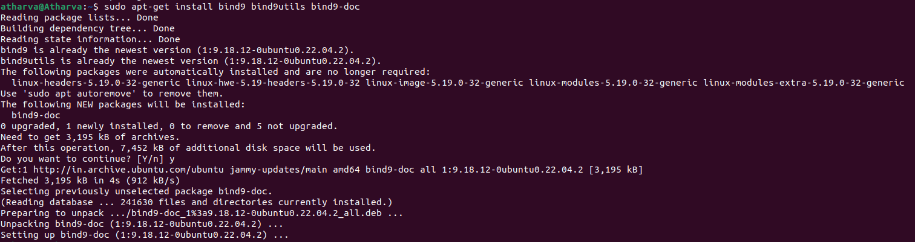

**Step 3:** Configuring the caching name server, caching name server saves the DNS query results locally for a particular period of time. To configure caching name server, edit /etc/bind/named.conf.options file. Which will be done by the following command.

sudo nano /etc/bind/named.conf.options

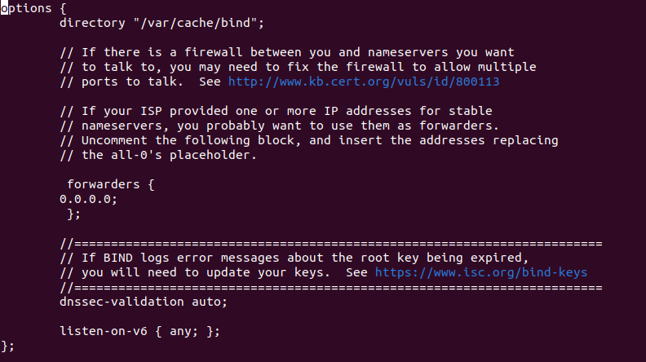

**Step 4:** Now restart the bind9 service to take effect the changes. This will be done by following command

sudo systemctl restart bind9



sudo systemctl status bind9

